Silicon is found in nature in the forms of ________
A. body-centered cubic structure
B. hexagonal-closed packed structure
C. network solid
D. face-centered cubic structure
ANSWER: C
In face-centred cubic cell, a unit cell is shared equally by __________
A. four unit cells
B. two unit cells
C. one unit cell
D. six unit cells
ANSWER: D
Which of the following is FCC?
A. 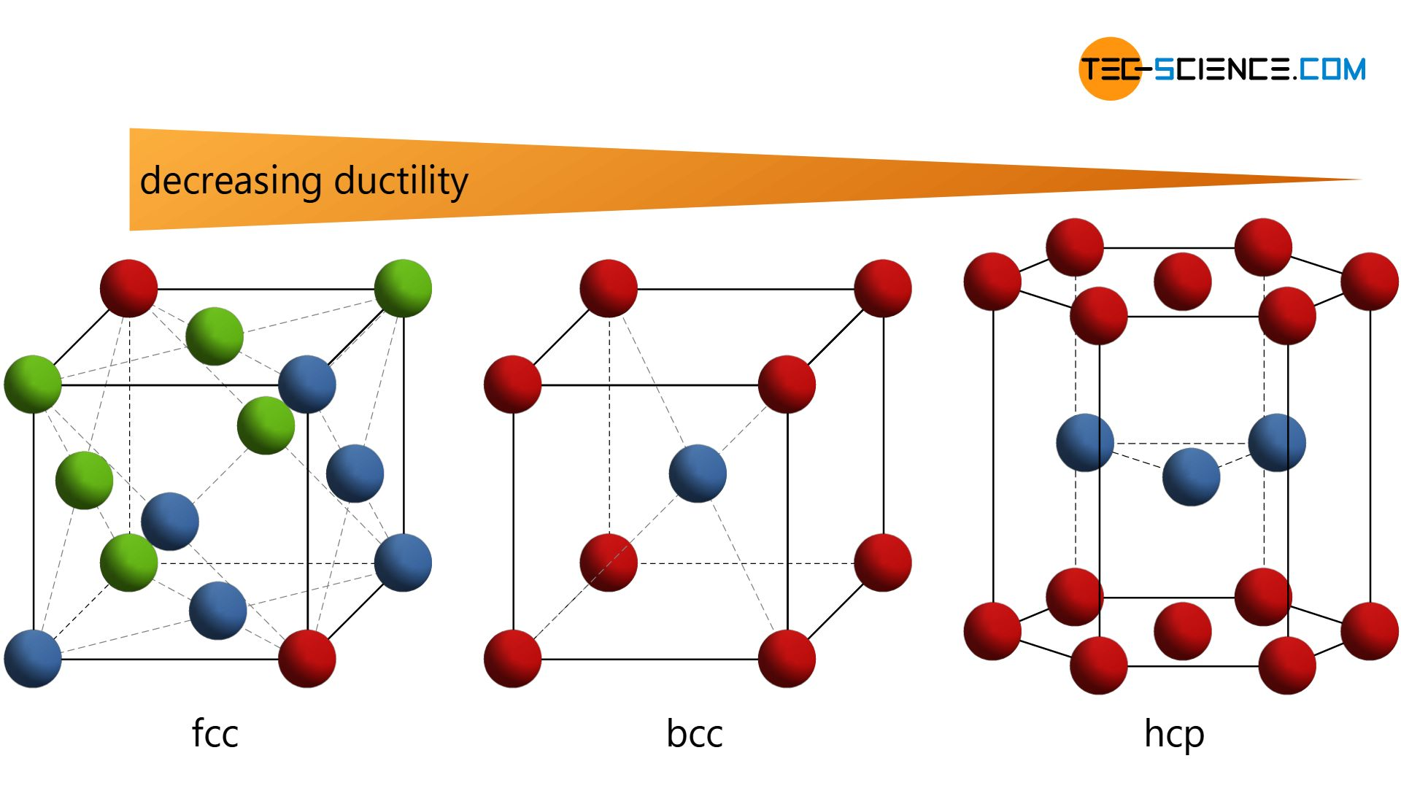
B. 
C. 
D. None of these
ANSWER: C

The crystal structure of brass is
A. FCC
B. BCC
C. HCP
D. Orthorhombic
ANSWER: B
In ______ constituent particles are closely packed leaving the least amount of vacant spaces.
A. plasma
B. liquids
C. solids
D. gases
ANSWER: C

What is the coordination number for one-dimensional close packing?
A. 2
B. 1
C. 4
D. 6
ANSWER: A

In how many ways, can the two-dimensional close packed structure be generated?
A. 3
B. 2
C. 1
D. 5
ANSWER: B

Which crystal would be made if the particles are arranged as given in the picture? 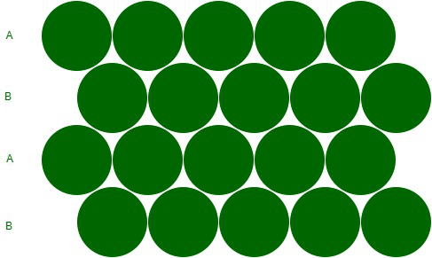
A. Hexagonal Close Packing
B. Face Centered Close Packing
C. Cubic Close Packing
D. Both A and B
ANSWER: A
Which of the following is BCC?
A. 
B. 
C. 
D. None of these
ANSWER: A

What is the coordination number for a two-dimensional square close packed structure?
A. 8
B. 4
C. 6
D. 2
ANSWER: B

What is the coordination number for a two-dimensional hexagonal close packed structure?
A. 4
B. 8
C. 12
D. 6
ANSWER: D

Voids in two-dimensional hexagonal close packed structure are ___________ in shape.
A. circular
B. rectangular
C. triangular
D. hexagonal
ANSWER: C
ABC-ABC arrangement is actually
A. Cubic open packing
B. Cubic close packing
C. Hexagonal open packing
D. Hexagonal closed packing
ANSWER: B
Cubic close packing of metal is known as
A. Hexagonal
B. Face centered cubic
C. Linear
D. Circular
ANSWER: B
Which of the following is HCP?
A. 
B. 
C. 
D. None of these
ANSWER: B



